JHH Biomedical On Call Cheat Sheet

**Contact Numbers:** 2

**Calendar Roster:** 3

**Equipment:**

* ECG machines 5
* Masimo Safety Net 5
* GE Patient Monitors 5
* Philips Patient Monitors 6
* Philips CTG IntelliSpace 8
* Re-Installing Philips Operating System and Application Software 9

The on-call roster will be for one week at a time from Monday to Monday

We only give after hours support to John Hunter Hospital. Calls from other hospitals (i.e. the Mater) will need to contact the Director or Deputy Director directly to obtain permission for us to assist them. You can give other hospitals phone support if you wish.

To divert the phone to your personal mobile: go into the Menu, Settings, Call, Call forwarding then Always forward

To cancel the diversion: repeat the above process but click disable on the last step.

If you get a phone call from staff member in JHH and they want you to come in, you will need to tell them to contact the JHH after hours manager and then the after hours manager will contact us if they deem it necessary for a call out. Please write down the name of the after hours manager that authorises you to come in, as you will need this for the paperwork.

To access the hospital IT network from home using your personal/work laptop, you just need to turn on the wifi hotspot on the on-call phone and then connect your laptop to that wifi network. On the phone simply toggle the “Hotspot” button on the home screen. The SSID is: “biomed oncall” and the password is: “bbroyg123456”

**Equipment:**

ECG Machines:

* Philips TC-50 – There are 23 TC-50’s in JHH, if a ward breaks theirs, they can borrow from another ward. Service password is “biomed” and Wifi password is: “SUMMIT”
* Mortara – Password is “hnebiomed”
* Mindray R12 – service password is “888888”

Masimo Safety Net System (Wards J1, J2 and H1)

* Error: “Paging console link down”

1. Contact Xacom on (03) 9265 4900 and see if they can reset their paging server. They will probably ask you to send through a test page.
2. If that doesn’t fix it, get the nurses to plug head phones into the Masimo PC which will silent the alarm and deal with it in the morning.

GE Patient Monitors

* Username: “biomed” Password: “Change Me”
* Update time – on any of the monitors/Aisys machines. The Aisys machines are stand alone, so you will need to connect up a mouse and keyboard to each machine individually and change the time. The monitors in JHH and RNC recovery and networked, so all you need to do is change the time on one of the monitors in each respective unit JHH and RNC and the monitor time will update on all the monitors.

Philips Central Monitoring

* Keyboard not working/only some keys on the keyboard working – reboot the central by pulling out the power cord or holding the power button in on the front.
* Buttons minimised as pictures below, get the nurses to toggle the ctrl/alt/shift key on the keyboard.

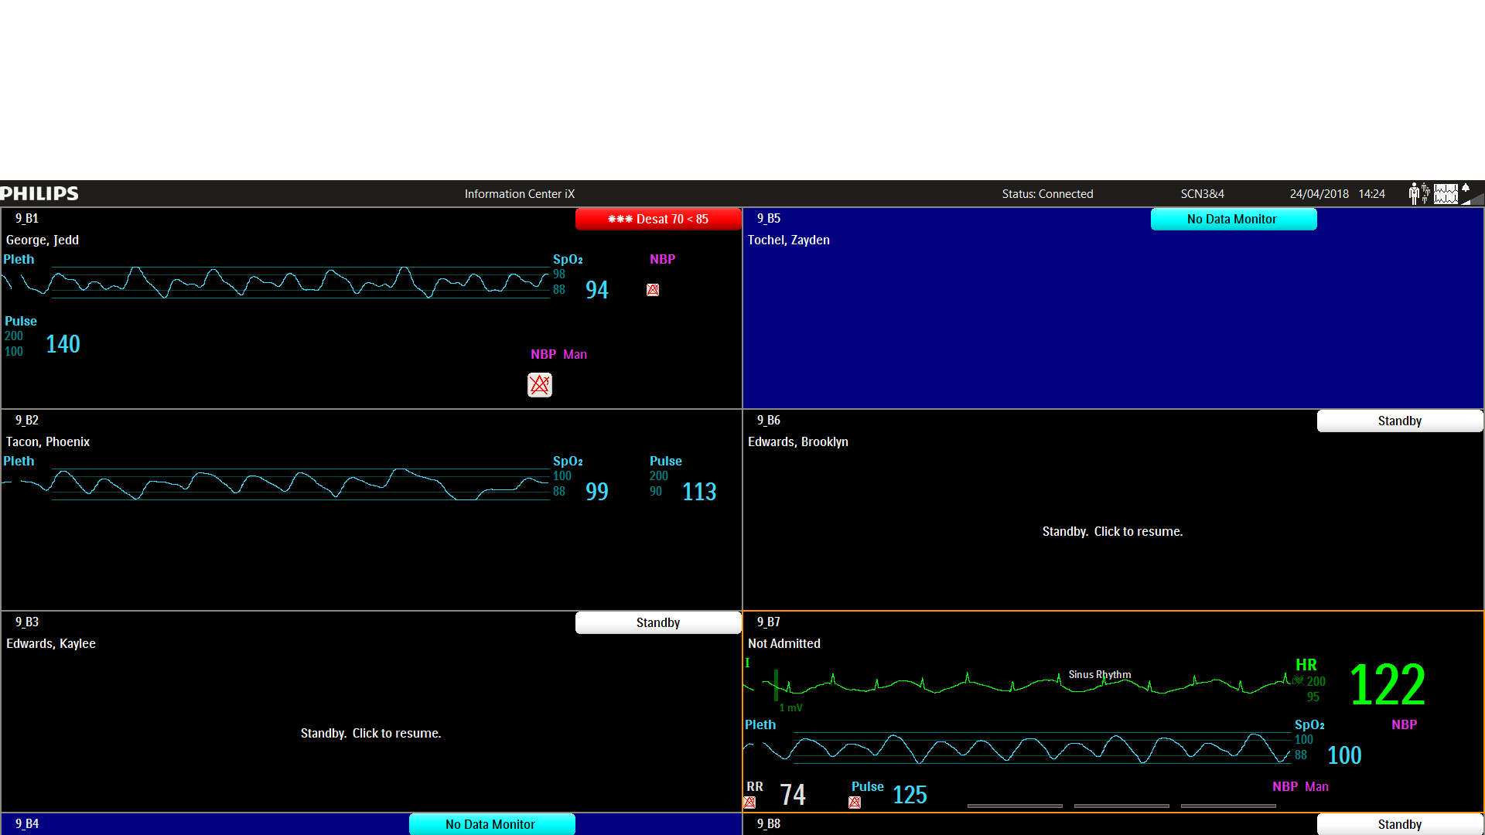

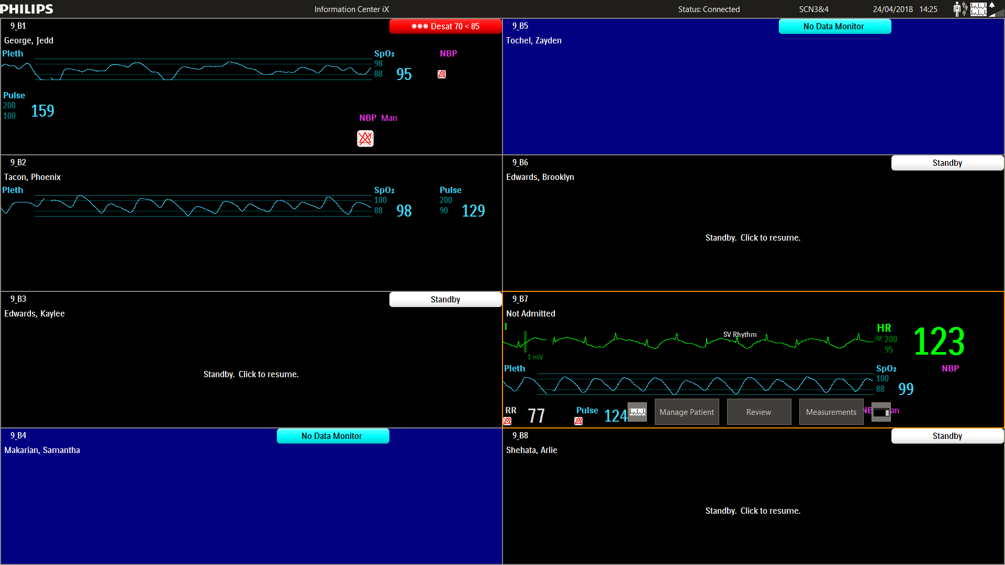

* Central monitor showing yellow banner saying local mode, disconnected from server. Could be a system wide Philips problem for just localised to that particular ward. Troubleshoot by trying to ping “JHHNSWJHDBS” from another computer in the ward. Or Ringing another Philips ward and seeing if they are disconnected.
* Bedside monitor not communicating with central – Hollow upper square means no connection to the central. A normal icon should have the upper rectangle solid.

Normal Icon: Abnormal Icon:

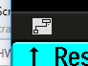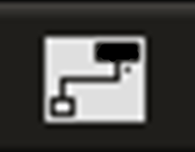

* Monitor at central station displaying “SmartImage” or a scrolling vertical line.

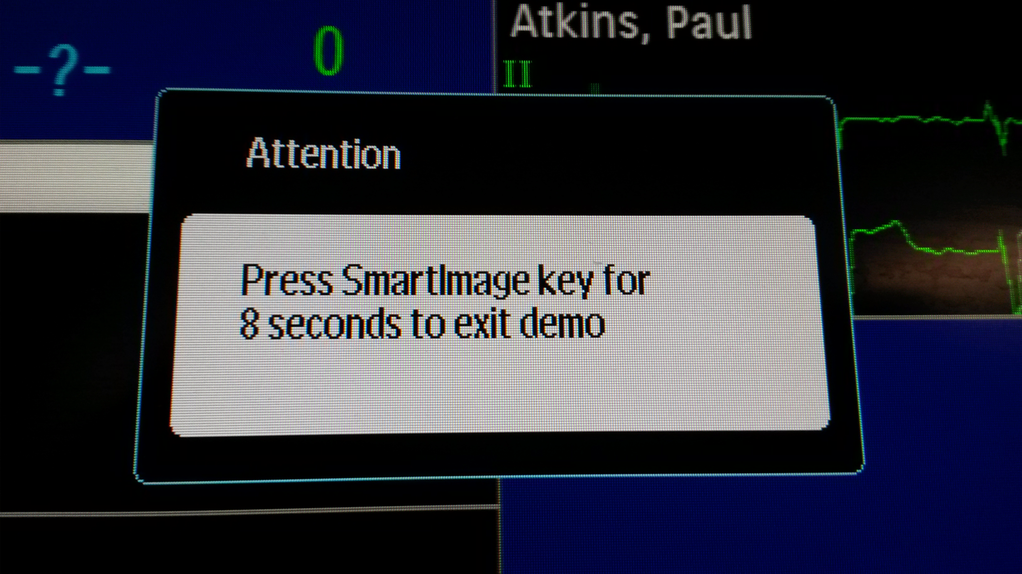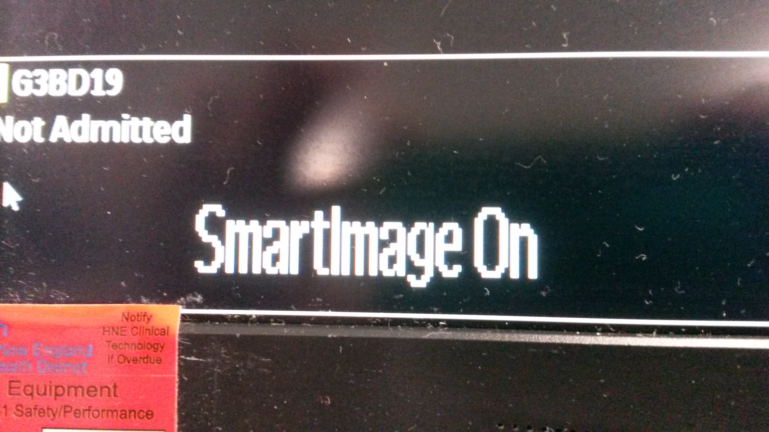

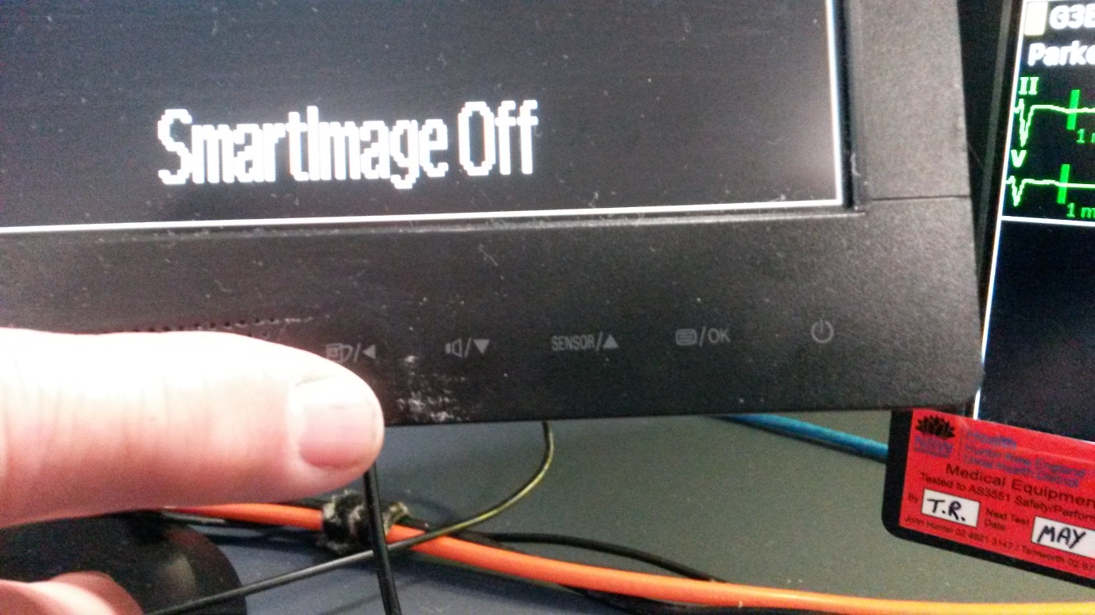

To turn off this annoying sales feature in the monitor, hold the left most button for approximately 8 seconds. This doesn’t always work so you can simply pull the mains power cord from the back of the monitor to reset it.

* If you need to recover/rebuild a central/server that has crashed, refer to appendix A.

Philips CTG IntelliSpace

* If there is a problem with the system. Troubleshoot to see if the problem is with one CTG machine for with the system or with the network port in the patient room. Only problem we care about is if a machine is faulty. If so get the staff to isolate it and we will look at it in the morning.
* See appendix for Instructions on how to restart the IntelliSpace Software.

Appendix A

Re-Installing Philips Operating System and Application Software

* With the Central/Server PC turned off insert the media that contains the Philips software (currently B.02.09) into the appropriate USB port. Turn on the PC. Press F9 to select the boot menu (Centrals press F9, Servers press F11). Select the USB drive and boot from it.
* A Windows Installer dialog opens and describes the actions that will occur if you click OK. Click OK to begin Installation or Cancel to quit.

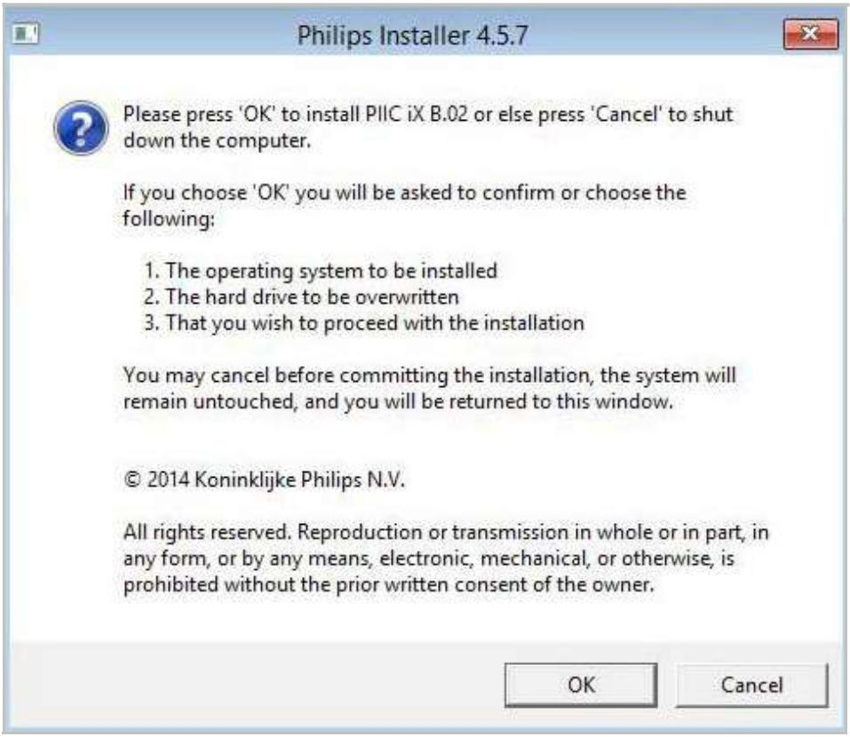

* Once the destination Disk is discovered, the installer displays the following screen. To continue the installation click OK, or click Cancel to quit.

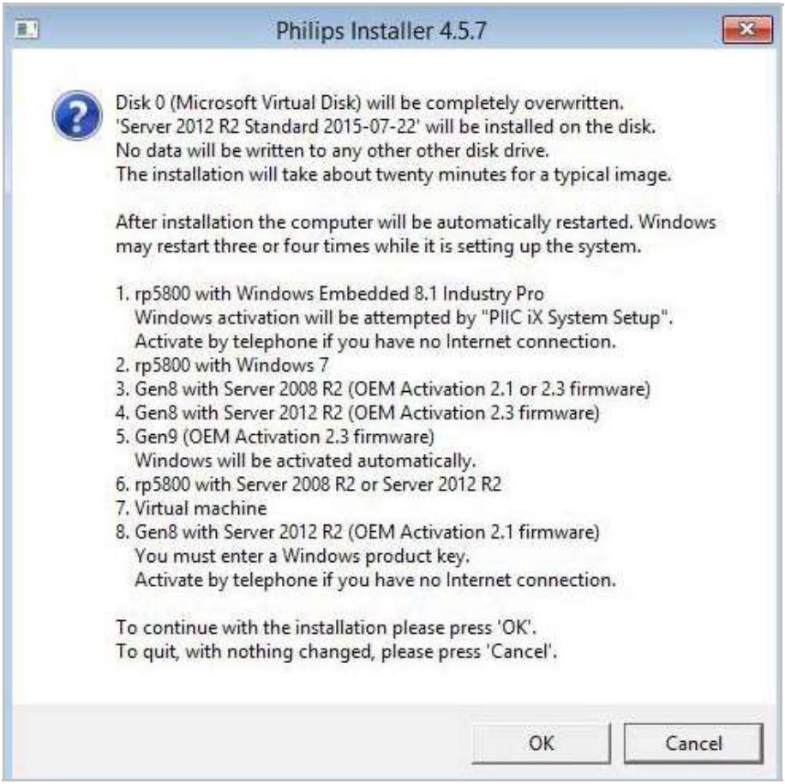

* The Installer now formats the drive and exports and applies the appropriate Operating System image.

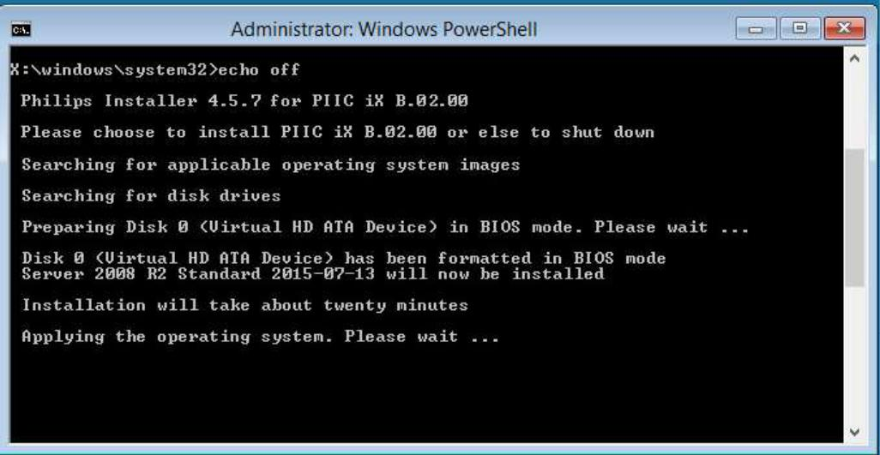

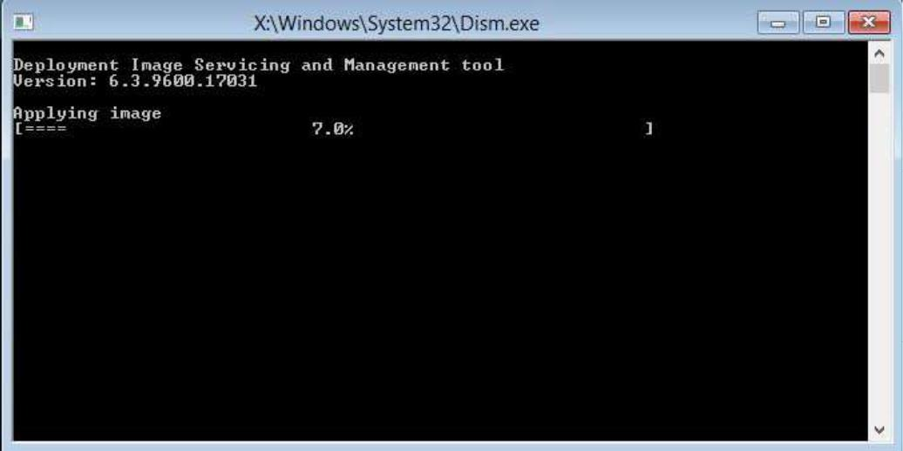

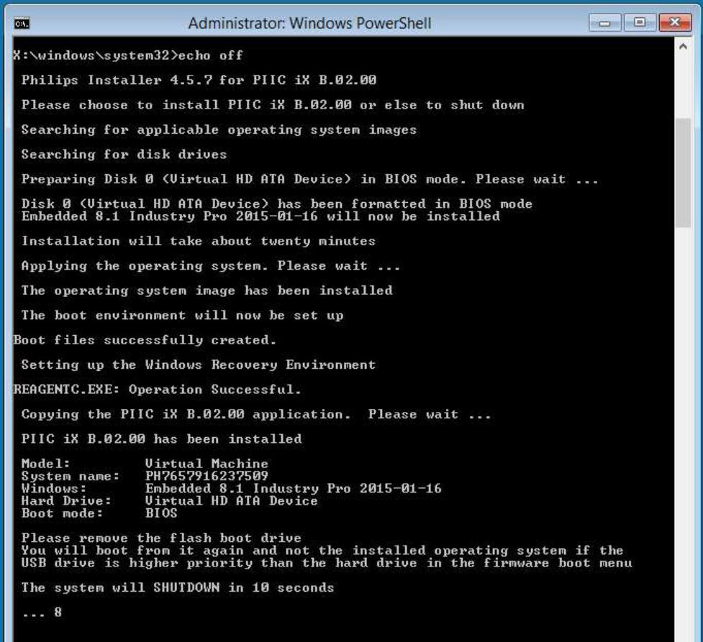

* When PIIC iX installation completes the status appears in the PowerShell screen. An alert that the system will reboot in 10 seconds appears.
* After PIIC iX application software files are installed the initial PIIC iX System Setup screen opens. Cancel out of System Setup.
* You need to upgrade the central/server to the latest software patch. Obtain the update files from another central or server. (C:\Program Files (x86)\Philips\PIIC iX\B.00\Product\Updates) Ensure you copy both the .exe file and the version.xml file.
* If you get prompted to Activate windows, then activate it. Otherwise don’t worry about it.
* You are now ready to plug the central/server into the network port and run system setup.

* The first screen prompts you to verify the hostname and IP Address settings. Access the Philips excel spreadsheet on the work centre/Technical Information Centre/Under the IP Addressing section select Philips. Enter the correct hostname for the central/server. Edit the IP address V4 settings by opening up the network adapter configuration. Enter the IP address, subnet mask and default gateway, as well as the 2 DNS servers, see below example. Then click advanced, and open up the DNS tab. Click: “Append these DNS suffices, and enter the domain: “hneahs.nswhealth.net”, see below picture.

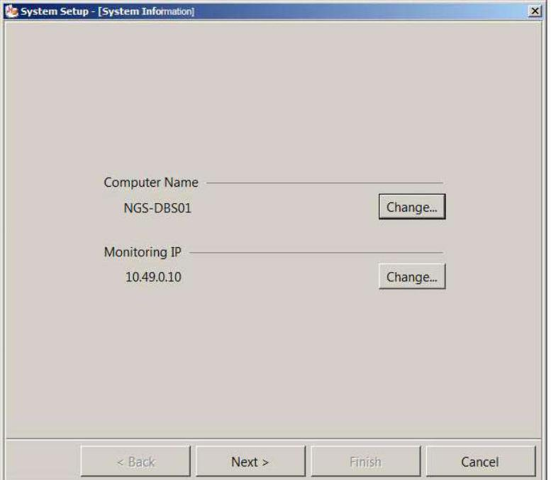

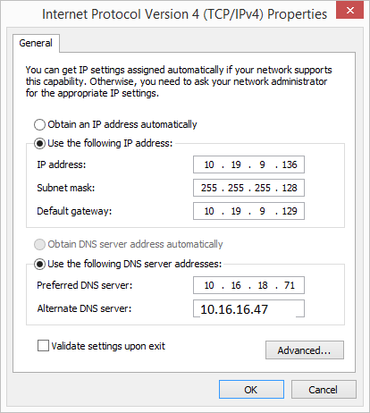

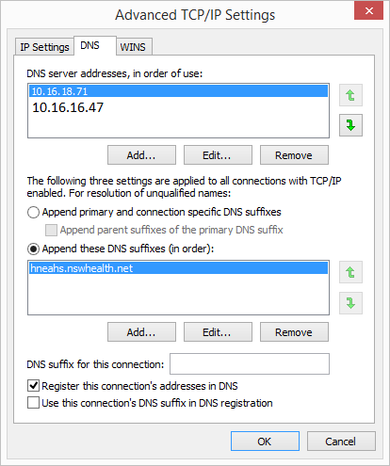

* If you experience any link speed (half/full duplex) errors, then you might need to edit the settings in the network adapter. If not, don’t worry about it.

1. In the Local Area Connection Properties sheet click Configure. Then click the advanced tab.

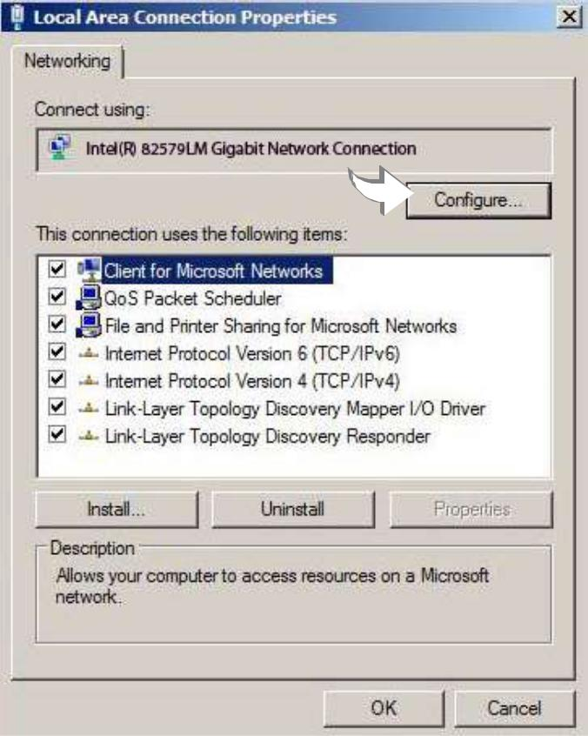

* On the Advanced tab select Speed & Duplex in the Property list.

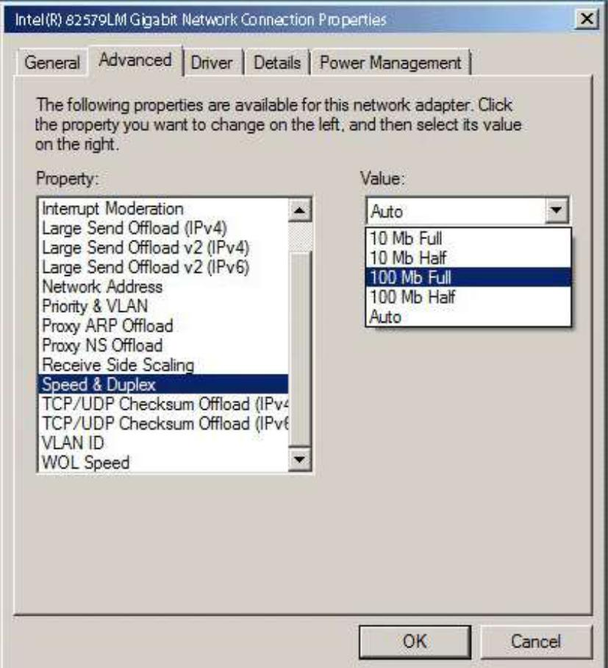

Important The setting you choose in the Value list must match any hard-coded setting on the network switch that you are connecting to. Philips recommends that you use Auto as the Value for Speed & Duplex. Host Qualification will negotiate the necessary Value for you.

* If you select a value other than Auto you must enable the Legacy Switch Compatibility Mode property by selecting it in the Property list, then clicking the down arrow and selecting Enabled.

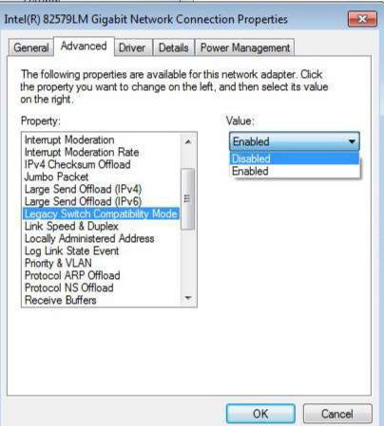

* When desired information is complete, click OK. Then close open dialogs. 4 Click Next > in the System Information screen to continue with system setup.

* Language Selection – Only change Regional Settings to English (Australia) Click Next > in the Language Selections screen to continue.

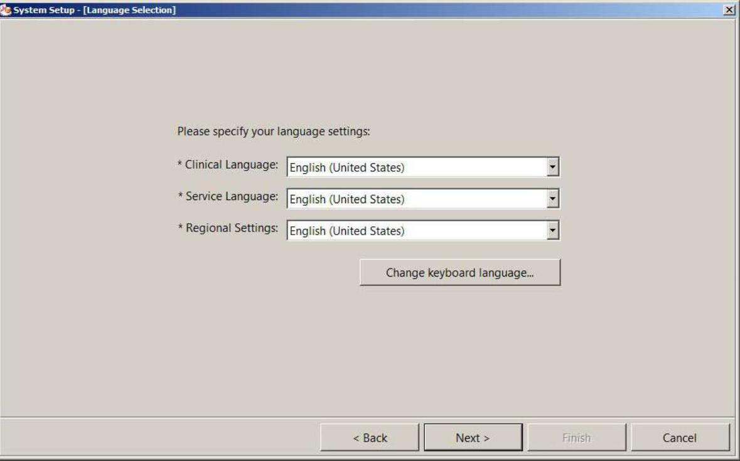

* Database Installation

In the Database Installation screen click Install. A progress bar appears. When databases are successfully installed the message, Databases installed successfully appears. Click Next > to continue.

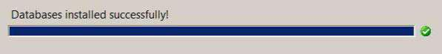

* Connect to Server
* In the Connect to Server page select “other host” and enter the primary server: “JHHNSWJHDBS”. All the configuration and archiving files will be downloaded from the primary server making the setup easier.

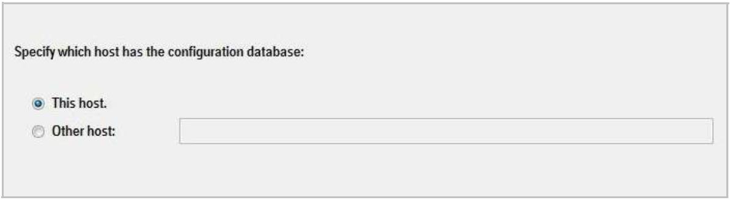

* Date & Time Settings – Leave time sync server unticked and do not adjust date and time, just click next as the server will update its time.
* 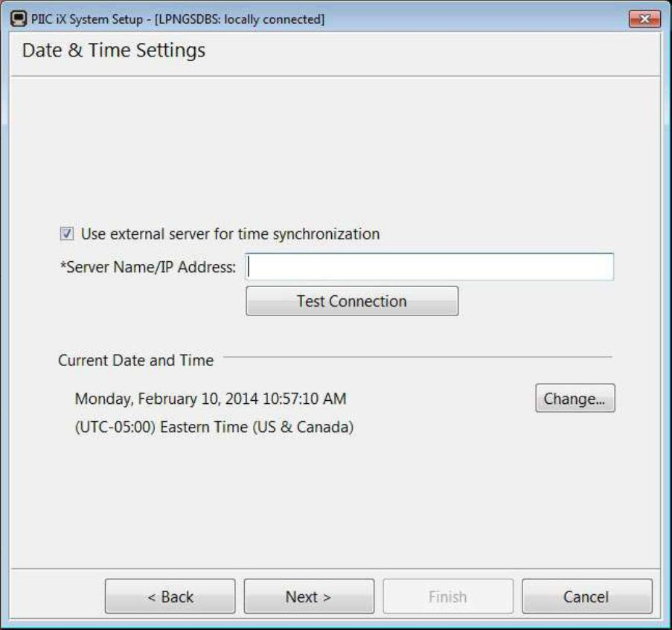
* Topology Configuration – You should not need to touch this screen, the server should have provided all of this configuration detail. You should be able to see the configuration sucked from the server. Click next.
* License Configuration – You should not need to touch this screen, the server should have provided all of this configuration detail. You should be able to see the configuration sucked from the server. Click next.
* Feature Assignment – You should not need to touch this screen, the server should have provided all of this configuration detail. You should be able to see the configuration sucked from the server. Click next.
* Display Configuration – The Display Configuration screen permits selection of Display settings.

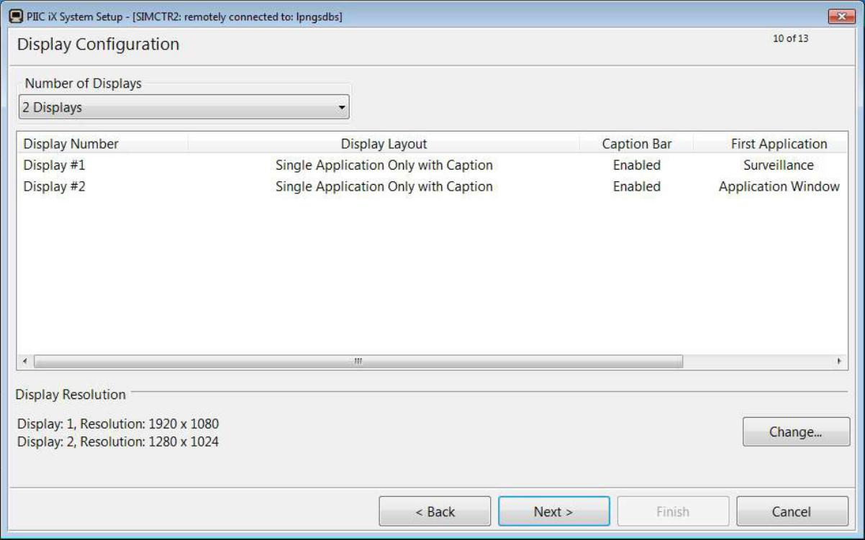

* You should not need to touch this screen, the server should have provided all of this configuration detail. You should be able to see the configuration sucked from the server. Click next.
* Peripheral Configuration

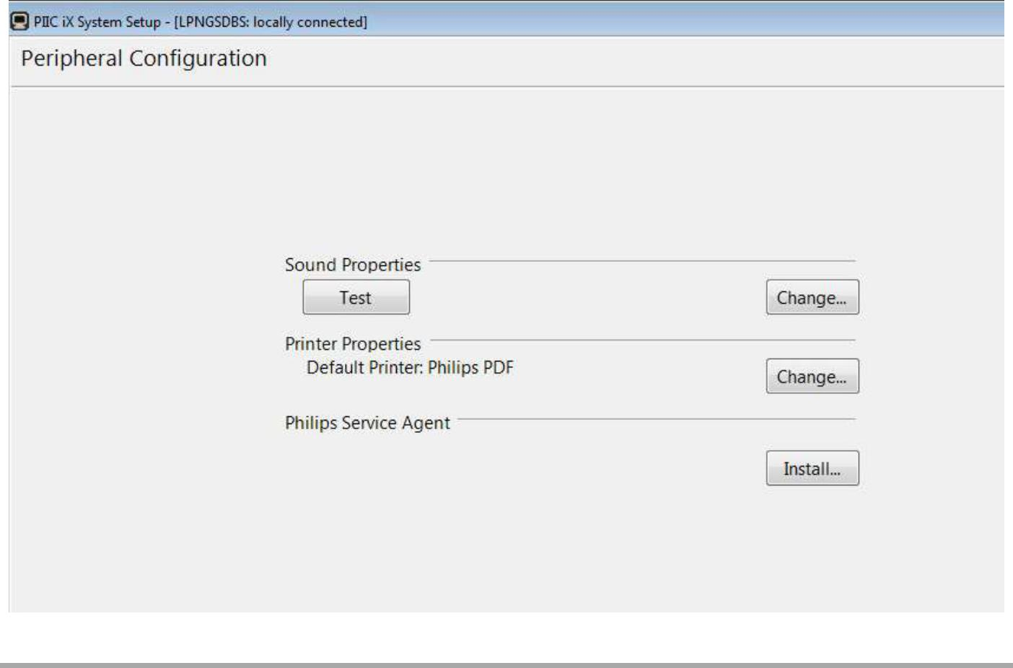

* Click the Test button to check the audible alarm tone. Then click the tick box
* If you wish to edit the printer, you can add the printer now, or add it after the system setup.
* Platform Security – Verify and Correct errors.

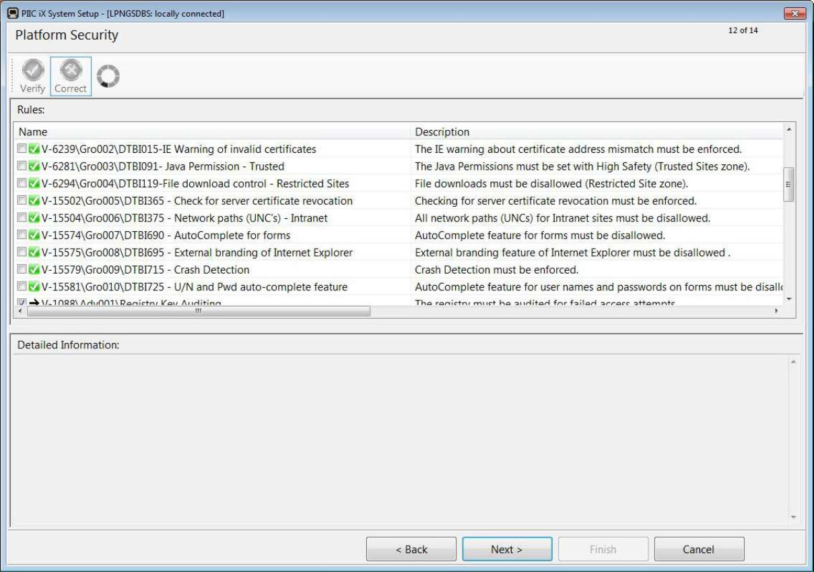

* Host Qualification – Verify and Correct errors.

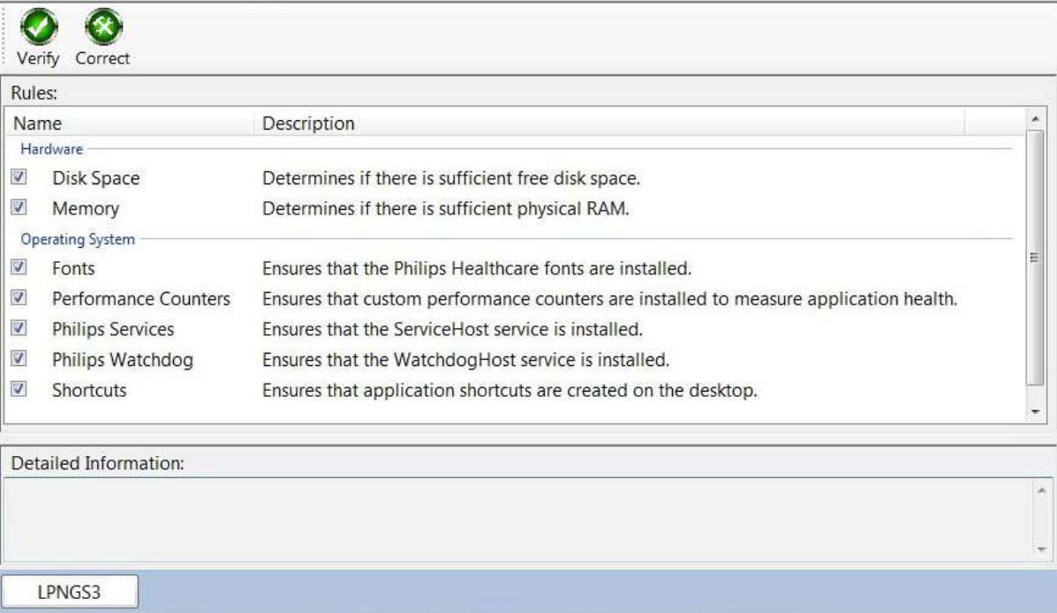

* Setup Complete – Simply reboot the central/server to begin patient monitoring.